Ahmed Abdelmonem Abdelhalim

Junior Data Analyst & BI Specialist

ahmedabdelmoneim260@gmail.com | WhatsApp:(+20)1125422549 | Phone:(+20)1030771136

Naser City, Cairo, Egypt | [www.linkedin.com/in/ahmedabdelmoneim260](http://www.linkedin.com/in/ahmedabdelmoneim260) <https://www.datascienceportfol.io/ahmedabdelmoneim260> | <https://github.com/ahmedabdelmoneim22>

# Summary

**A Junior Data Analyst & BI Developer** with a strong foundation in Computer Science. Passionate about providing meaningful business insights and supporting informed decision-making. Proficient in **SQL, Python, Excel, Power BI and BI tools to extract, transform, load and analyze data.** Skilled in creating interactive dashboards and reports that deliver actionable insights to stakeholders.

**Education**

**Bachelor of Computers and information, Computer Science major** [MTI University](https://www.mti.edu.eg) **Sep 20' |** **July 23'**

# Experience

**Data Analyst intern** **Agouza Rehabilitation&Rheumatology** **Center(****ARRC)**  **Dec 24' | Jan 25'**

**Technologies:** (Python,Excel,Power BI)

• Patient Satisfaction Survey **Analysis** of Outpatient Services.

I created a project to analysis patient satisfaction survey of outpatient services with **python**.

The program read paper from **scanner** then transform it into values then I made analysis on every question in paper

than Display **Yes** and **No** Percentages. Help **providing meaningful insights** about patients satisfaction.

[**Projects**](https://ahmedabdelmoneim22.github.io/index/)

[**Preview Portfolio**](https://www.datascienceportfol.io/ahmedabdelmoneim260)

## [E-commerce Database Management System](https://drive.google.com/file/d/1C_ovhbQPQwbY-USdj9zZ7N7RPtcYiiUd/view) Using SQL Server, SSIS, SSAS & SSRS

* Created a (**DBMS**) project, including an Entity-Relationship Diagram (**ERD**) and Mapping.
* Used **SQL** for implementing **OLTP**, and **Datawarehouse** **OLAP** components.
* Managed challenges related to **data integration**, scalability, and complex data transformations.
* Used (**SSIS**) for seamless data extraction, transformation, and loading processes.
* Used (**SSAS**) to make **cubes** and (**SSRS**) to provide intuitive **insights** and **reports** for end-users.

[**Restaurant Sales Analysis Project**](https://github.com/ahmedabdelmoneim22/Restaurant-Sales-Analysis-Project)Using Microsoft Power BI

* Designed business overview and Restaurant performance **dashboards** in **Power BI**.
* help in enhance **sales strategies** and make **data-driven decisions**.

[**Customer Churn Analysis Project**](https://github.com/ahmedabdelmoneim22/Customer-Churn-Analysis-Project/tree/main)Using Microsoft Power BI

* Designed business overview and Restaurant performance **dashboards** in **Power BI**.
* Presented compelling **insights** that drive informed decision-making.
* Following customer behavior to know the rate at which customers leave a business compared to the total number of active customers and using techniques to attract customer once agent.

[**Human Resources Analysis Project**](https://github.com/ahmedabdelmoneim22/Human-Resources-Analysis-Project/tree/main)Using Microsoft Power BI

* Demonstrated expertise in data importing and **modeling** within **Power BI**.
* The report provides an analysis of employee turnover in a company, detailing the turnover rates by year, reasons for termination, average salary, and demographic breakdowns such as gender, education level, and location.
* It also highlights key metrics like the overall turnover rate of 29.17% and an average salary of $4.11K.

## [**Carrefour Web Scraping With Python**](https://github.com/ahmedabdelmoneim22/Carrefour-Web-Scraping-With-Python) **- WebScraping** Using Python

* Created a **WebScraping** script using **Python**, **Requests**, and **BeautifulSoup** to collect the data.
* **Extracted** **data** including product names, regular and sale prices, sale percentages, sizes, and colors.
* Implemented pagination handling to **scrape** data from **multiple pages** and ensured data consistency.
* Generated a **CSV file** to store the collected data for potential **business analysis**.

## [**Weather Data Analysis Project**](https://github.com/ahmedabdelmoneim22/Weather-Data-Analysis-Using-Python-Project)using Python Pandas

## derive meaningful insights and patterns from the dataset

## and use various**pandas functions** and methods to manipulate and **analyze the data**.

## [**Coffee Machine OOP Project**](https://github.com/ahmedabdelmoneim22/Coffee-Machine-OOP-Project)using Python OOP

## Used **OOP** With **Python** to make Coffee Machine Project, Using **Classes** and **Objects**.

## Technical Skills

* **Technologies:** (SQL Server, Visual Studio, Power BI, Excel, PyCharm, Subline and Project Jupyter)
* **Structure Query Languages: SQL Server** (SQL statements, Join, Grouping, Aggregate Functions, Union,

Subqueries, Ranking Functions, Constraints, Rules, Variables,

IF, While, Functions, View, Stored Procedure, Index, Trigger,

Cursor, Jobs, Snapshot, Backup & Restore)

* **Database Design:** (Normalization, ERD, EERD, Mapping, Creation & Implementation, OLTP)
* **Familiar with Datawarehouse:** (ETL, Data Mart, OLAP, Star Schema, Snowflake Schema, Fact & Dim)
* **Python Programming Language:** Python (Pandas, NumPy, Matplotlib, Tkinter, OpenCV)
* **Web Scraping:** With Python (BeautifulSoup, Requests, Selenium WebDriver)
* **Data Visualizations tools:** Power BI (Data Sources, Power Query, Data Modeling, DAX, Reports and Dashboards)
* **BI tools: SSIS** (ETL, ELT, Star Schema, DWH, Data Marts),

**SSAS** (Cubes, KPI’s, Hierarchies, Calculations, OLAP) &

**SSRS** (Reports)

* **Microsoft Excel:** (Pivot Tables, Advanced Functions, Nested Functions and Dashboards)
* **Version Control System:** Git & GitHub
* **Familiar with:** (C++ Programming Language, HTML & CSS, SQLAlchemy & SQLite)
* **Soft Skills:** (Continuous Learning, Leadership, Teamwork, Hardworking & Time Management)

# Certificates

* [Data Literacy Essentials](https://www.credly.com/badges/a4369dd2-bcd9-4a7f-9f45-884cb08c8eb3)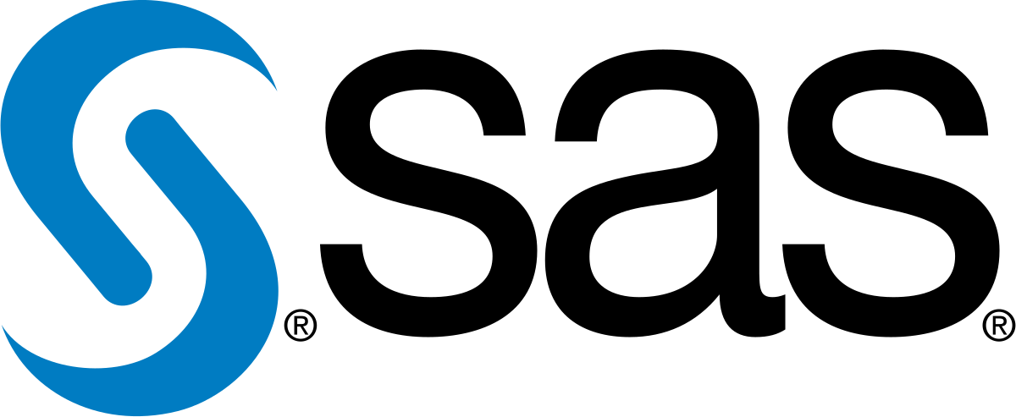
* [Artificial Intelligence (60 hrs.)](https://drive.google.com/file/d/1-SPZO35hfacA5fC6iox0rzk6gj2g5yWy/view)
* [100 Days of Code: The Complete Python Pro Bootcamp for 2023](https://drive.google.com/file/d/1OHYkkC080pHvpjQ-1imQoJEXPxiMB29g/view)
* [Database and SQL Fundamentals](https://drive.google.com/file/d/1F_WN8tPXA8-xMDLoBclvo-FozN3G2Jm4/view)